Mini Project: Cohort 21: Affordable Housing Price Estimator
Date: 27.02.2026

Data Preprocessing
In this phase, the Bengaluru Housing dataset was prepared for building the Machine Learning model. Data preprocessing is a crucial step that ensures the dataset is clean, consistent, and suitable for analysis. Initially, essential Python libraries such as Pandas and NumPy were imported to perform data manipulation and numerical operations efficiently. The dataset was loaded using the read_csv() function and stored in a DataFrame for further processing.
During the data exploration stage, the dataset was examined for missing values, inconsistencies, and irrelevant features. It was observed that the society column contained more than 40% missing values, which could negatively affect the model’s performance. Therefore, this column was removed to improve overall data quality. Additionally, the total_sqft column included range values (for example, “2100–2850”) instead of single numeric values. These ranges were converted into single numerical values by calculating their average, ensuring uniformity in the dataset.
Missing values in important columns were handled using appropriate statistical methods to maintain data integrity. The bath column was filled using the median value to minimize the influence of outliers. The balcony column was filled using the mode, representing the most frequently occurring value. Similarly, the size column was filled using the mode, as it reflects the most common property size in the dataset.
Outlier detection was also performed to remove unrealistic entries that could distort the model’s predictions. Properties with more than 10 bathrooms or more than 10 BHK were considered impractical for typical residential housing and likely resulted from data entry errors; therefore, these records were removed. This step improved the reliability and accuracy of the dataset.
Finally, the cleaned and processed dataset was saved as a new CSV file for use in subsequent stages such as Exploratory Data Analysis (EDA) and Machine Learning model development. After preprocessing, the dataset became structured, accurate, and ready for building the Affordable Housing Price Estimator, supporting the objectives of SDG 11 – Sustainable Cities and Communities by enabling data-driven insights into housing affordability.

Importing Libraries
In this step we imported two important Python libraries called Pandas and Numpy. Pandas is used to load and work with our dataset just like how we use Microsoft Excel to handle data. Numpy is a mathematical library that helps us handle numbers and missing values. These two libraries are the foundation of any Data Science project and without them we cannot process our data.

Loading the Dataset
After importing the libraries we loaded our Bengaluru Housing dataset using the read_csv() function from Pandas. This function opens the CSV file and stores all the data in a variable called df which stands for DataFrame. A DataFrame is basically a table with rows and columns just like an Excel sheet but inside Python. Our dataset had 13,320 rows and 10 columns when we first loaded it.

Dropping the Society Column
When we explored the dataset we found that the society column had 5,502 missing values out of 13,320 rows which means 41% of the data in that column was empty. In Data Science when a column has more than 30 to 40 percent missing values it is considered not useful and should be removed. So we used the drop() function to completely remove the society column from our dataset. This helped us reduce unnecessary and incomplete information.
Fixing the total_sqft Column
During data exploration we noticed that some properties had their square footage written as a range like "2100-2850" instead of a single number. This happened because builders sometimes give a range of sizes for different units in the same building. Since Python cannot perform mathematical calculations on text values like "2100-2850" we wrote a function called convert_sqft() to fix this. The function splits the range into two numbers, calculates their average and replaces the range with a single numeric value. For example "2100-2850" becomes 2475 after taking the average of 2100 and 2850.
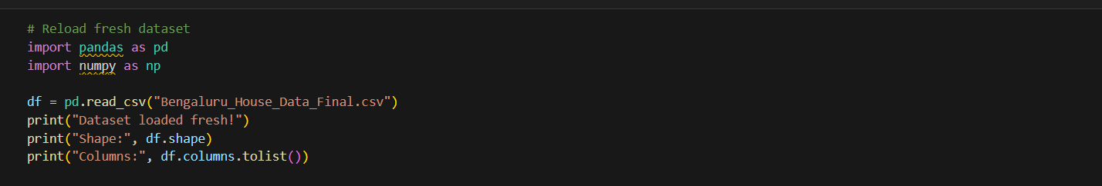
Filling Missing Values
Some columns in our dataset had missing or empty values which we cannot leave as they are because Machine Learning models cannot work with missing data. So we filled the missing values intelligently using different methods for different columns. For the bath column we used the median value because it had extreme outliers like 40 bathrooms which would affect the average. For the balcony column we used the mode which is the most frequently appearing value. For the size column we also used the mode because the most common property size in Bengaluru is 2 BHK. This way we filled all the missing values without losing any rows.
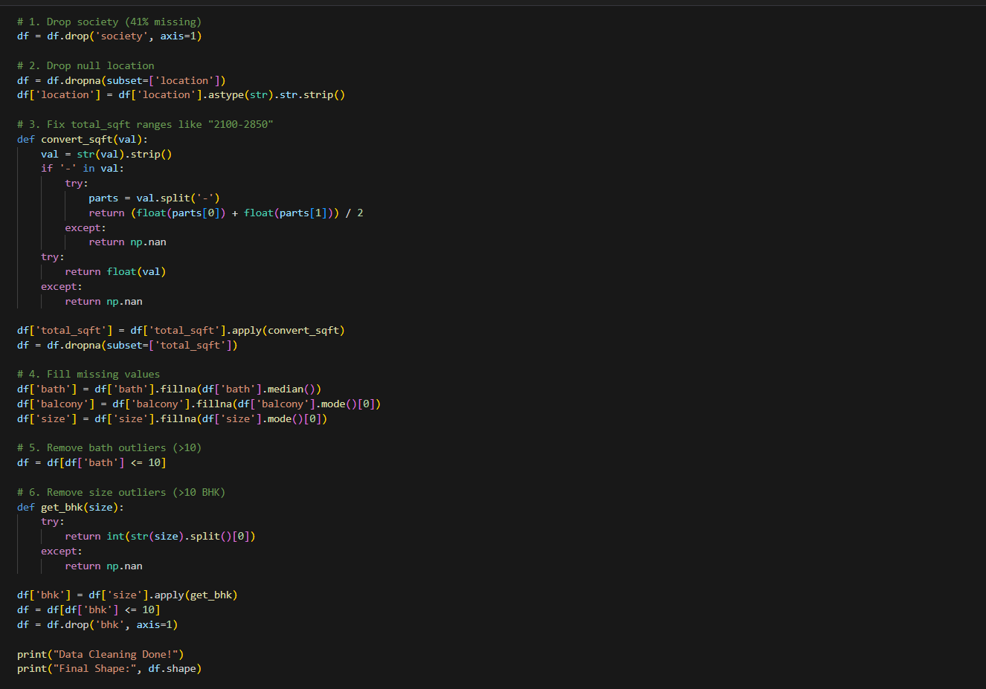
Removing Outliers from Bath Column
While checking the dataset we found that some houses had as many as 40 bathrooms which is clearly a data entry mistake and not realistic for a normal residential property. These extreme and unrealistic values are called Outliers in Data Science. Outliers can mislead our Machine Learning model and give wrong predictions. So we removed all the rows where the number of bathrooms was more than 10 since any house with more than 10 bathrooms is either a mistake or a very unusual case that does not represent normal housing in Bengaluru.
Removing Outliers from Size Column
Similarly we found that some properties had sizes like 43 BHK and 27 BHK which are completely unrealistic for normal residential housing. We wrote a function called get_bhk() that extracts the number from values like "2 BHK" and gives us just the number 2. Using this function we identified all properties with more than 10 BHK and removed them from the dataset as they were clearly wrong data entries. After removing these outliers we also dropped the temporary bhk column that we created since it was only needed for filtering.
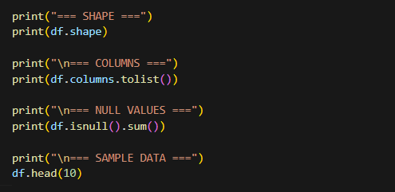

Saving the Cleaned Dataset
After completing all the cleaning steps we saved our cleaned dataset as a new CSV file called Bengaluru_House_Cleaned.csv using the to_csv() function. This ensures that our original dataset remains unchanged and we have a separate clean version ready for the next steps which are Exploratory Data Analysis and Machine Learning Model Building. The index=False parameter makes sure that the row numbers are not saved in the file.
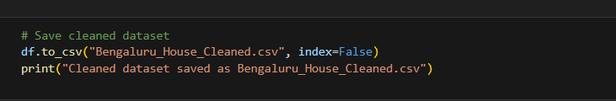
Summary
Overall our data cleaning process transformed a raw and messy dataset with 13,320 rows and multiple issues into a clean and reliable dataset with 13,250 rows and zero missing values. We removed the society column, fixed square footage ranges, filled missing values in bath, balcony and size columns, and removed unrealistic outliers. This cleaned dataset is now ready to be used for building our Affordable Housing Price Estimator model as part of SDG 11 — Sustainable Cities and Communities.

Processed Dataset:
